EXPERIMENT 9 :

Aim :

To demonstrate linear separability using python code.

Program :

import numpy as np

from sklearn.model_selection import train_test_split

from sklearn.linear_model import LinearRegression

from sklearn.metrics import mean_squared_error

import matplotlib.pyplot as plt

np.random.seed(42)

x=2*np.random.rand(100,1)

y=4+3*x+np.random.randn(100,1)

x_train,x_test,y_train,y_test=train_test_split(x,y,test_size=0.2, random_state=42)

model=LinearRegression()

model.fit(x_train,y_train)

y_pred=model.predict(x_test)

mse=mean_squared_error(y_test,y_pred)

print(mse)

plt.scatter(x_test,y_test,color='pink',label='Actual')

plt.plot(x_test,y_pred,color='yellow',label='Prediction')

plt.title('Linear Regression')

plt.xlabel('X')

plt.ylabel('Y')

plt.legend()

plt.show()

Output :

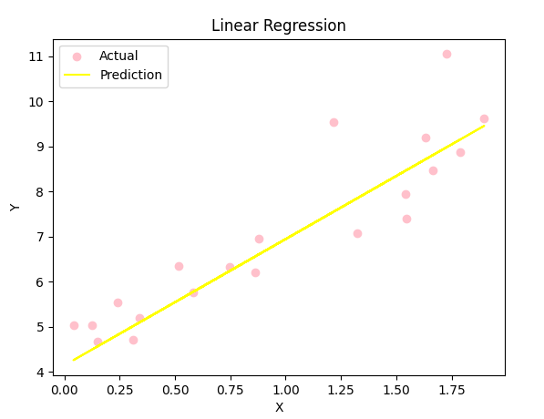

0.6536995137170021